[CEN 323 ] Computer Organization & Assembly Language
Lab 11 Journal

Name : Fatima Asad
Enrollment Number: 01-135232-020

Lab Deliverables (submission guideline)

Create a folder named after your enrollment number and add the following files:
  - Create a folder named YourRollNumber_Lab11 containing:
- .asm files of the three practice tasks.
- Add full screen screenshots of the code and output in this word file.
  - Zip the Folder and upload to LMS.

Lab Task

Task 1:
Code (TEXT):
org 100h

jmp begin

include emu8086.inc

num dw 0

begin:
PRINT "Enter a positive number: "
CALL SCAN_NUM
mov [num], cx

PRINTN ""

cmp cx, 1
jle is_not_prime
cmp cx, 2
je is_prime

mov bx, 2

check_loop:

mov ax, [num]
xor dx, dx
div bx

cmp dx, 0
je is_not_prime

inc bx
mov ax, bx
mul bx

cmp ax, [num]
jbe check_loop

jmp is_prime

is_not_prime:
PRINT "This is not a prime number"
jmp exit

is_prime:
PRINT "This is a prime number"

exit:
RET

DEFINE_SCAN_NUM
DEFINE_PRINT_STRING
DEFINE_PRINT_NUM
DEFINE_PRINT_NUM_UNS

END

Screenshot (CODE):
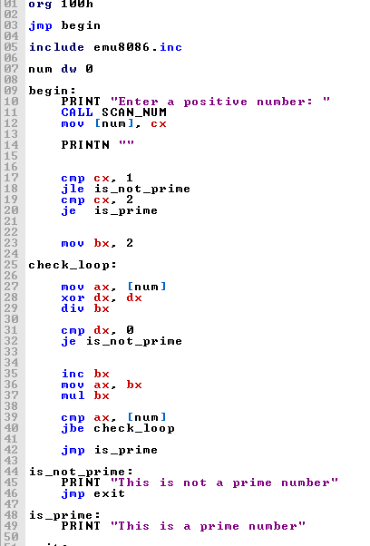

Screenshot (OUTPUT):
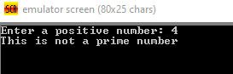

Task 2:
Code (TEXT):
include emu8086.inc
org 100h

jmp begin

a dw 2
b dw 7

begin:
printn "Numbers before swapping:"

mov ax, a
call PRINT_NUM
print " "

mov ax, b
call PRINT_NUM

call swap_proc

printn ""
printn "Numbers after swapping:"

mov ax, a
call PRINT_NUM
print " "

mov ax, b
call PRINT_NUM

mov ah, 4ch
int 21h

swap_proc proc
mov ax, a
mov bx, b

mov cx, ax
mov ax, bx
mov bx, cx

mov a, ax
mov b, bx

ret
swap_proc endp

DEFINE_PRINT_NUM
DEFINE_PRINT_NUM_UNS

Screenshot (CODE):

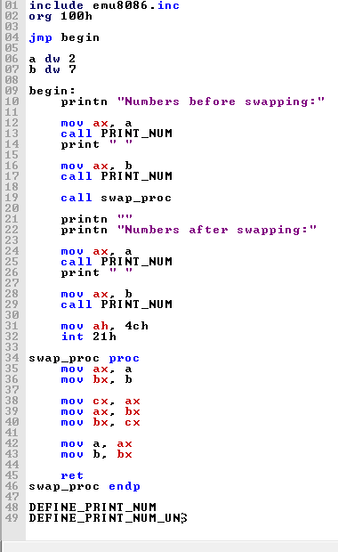

Screenshot (OUTPUT):
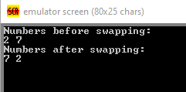

Task 3:
Code (TEXT):
include emu8086.inc
org 100h

jmp begin

arr db 5 dup(0)

begin:
printn "Enter any five numbers:"

mov cx, 5
mov si, 0

input:
call SCAN_NUM
mov arr[si], cl
inc si
loop input

call sortarray

printn ""
printn "Sorted Array:"

mov cx, 5
mov si, 0

output:
mov al, arr[si]
mov ah, 0
call PRINT_NUM_UNS
print " "
inc si
loop output

mov ah, 4Ch
int 21h

sortarray proc
mov cx, 4

outer:
mov si, 0
mov bx, 4

inner:
mov al, arr[si]
mov dl, arr[si+1]

cmp al, dl
jbe skip

call swap

skip:
inc si
dec bx
jnz inner

loop outer
ret
sortarray endp

swap proc
mov al, arr[si]
mov dl, arr[si+1]
mov arr[si], dl
mov arr[si+1], al
ret
swap endp

DEFINE_SCAN_NUM
DEFINE_PRINT_NUM_UNS

Screenshot (CODE):
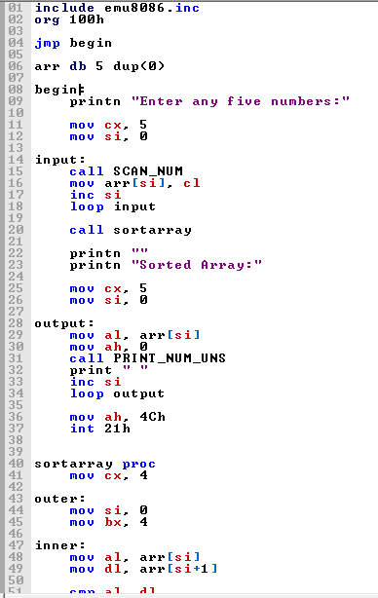

Screenshot (OUTPUT):
